

Kindergarten & 1st Grade Program

Location
Courageous Kicks Taekwondo
1225 Garden St.
Titusville, FL 32796
Courageous Character is a unique learning environment where students grow academically, physically, and spiritually. Our program blends strong academics, character development, and physical activity to help children build confidence and develop a lifelong love of learning.
Students enjoy a structured day filled with reading, writing, math, social studies, creative activities, and Taekwondo training.
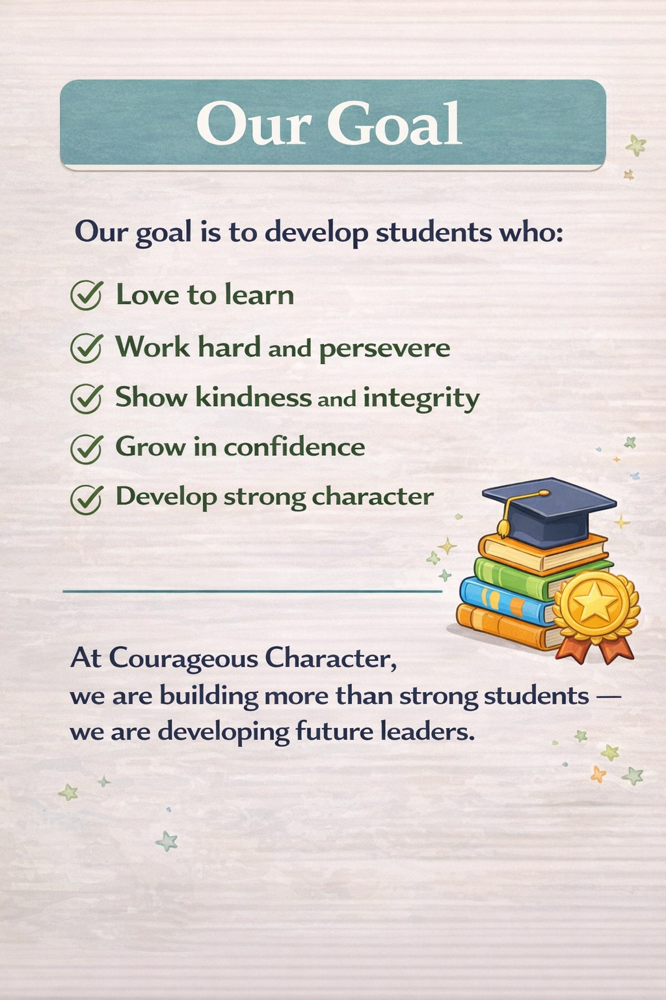
To provide individualized attention and strong relationships, class size is limited to 10 students.

About Courageous Character
At Courageous Character, we are dedicated to providing a safe and nurturing environment where children can learn, grow, and thrive.
Our focus is on helping students develop:
• Strong academic foundations
• Leadership skills
• Confidence and perseverance
• A love for learning
We believe that truth and wisdom begin with a strong foundation in faith. Students are taught Bible lessons and encouraged to see the world through a biblical worldview.
Through these lessons, children learn important values such as:
• Integrity
• Kindness
• Responsibility
• Respect for others
Our goal is to help students grow academically, physically, and spiritually while developing the character needed to make a positive impact in their homes, communities, and the world.

Our Academic Approach
Courageous Character supports homeschool families by providing structured academic instruction in a supportive classroom environment.
We use the Abeka curriculum as a guideline to build strong foundations in reading, writing, and mathematics.
Our classroom is designed to keep students engaged and excited about learning. In addition to traditional instruction, students participate in:
• Hands-on activities
• Interactive learning games
• Creative projects and crafts
• Movement-based learning
• Group activities that build teamwork and leadership
Our goal is for students to not only learn important academic skills, but also to enjoy learning and develop curiosity about the world around them.

Academic Subjects
Reading
Students develop strong literacy skills through phonics instruction and guided reading.
Students learn to:
• Recognize letter sounds
• Blend sounds to read words
• Build sight word vocabulary
• Read beginner books with confidence
• Understand and retell stories
Our goal is not only for students to learn to read, but to love reading.

Writing
Students learn that writing is a powerful way to express ideas, tell stories, and communicate clearly.
Students practice:
• Writing sentences
• Creating simple stories
• Drawing and writing to explain ideas
• Using capitalization and punctuation
• Sounding out and spelling words
These activities help students build confidence as writers.

Mathematics
Math instruction focuses on developing strong number sense and problem-solving skills.
Students learn to:
• Count and compare numbers
• Add and subtract
• Recognize patterns
• Identify shapes
• Solve simple word problems
Math is taught through hands-on activities and games that make learning fun and easy to understand.

Social Studies
Social Studies helps students understand the world around them and their role in their community.
Students explore topics such as:
• Families and communities
• Maps and geography
• American symbols and traditions
• Citizenship and responsibility
• Understanding past, present, and future
These lessons help students grow into thoughtful and responsible leaders.

Taekwondo Integration
A unique part of Courageous Character is the integration of Taekwondo training into the school day.
Taekwondo helps students develop:
• Discipline
• Focus
• Confidence
• Strength and coordination
• Leadership skills
The lessons students learn in Taekwondo reinforce the character qualities taught in the classroom.

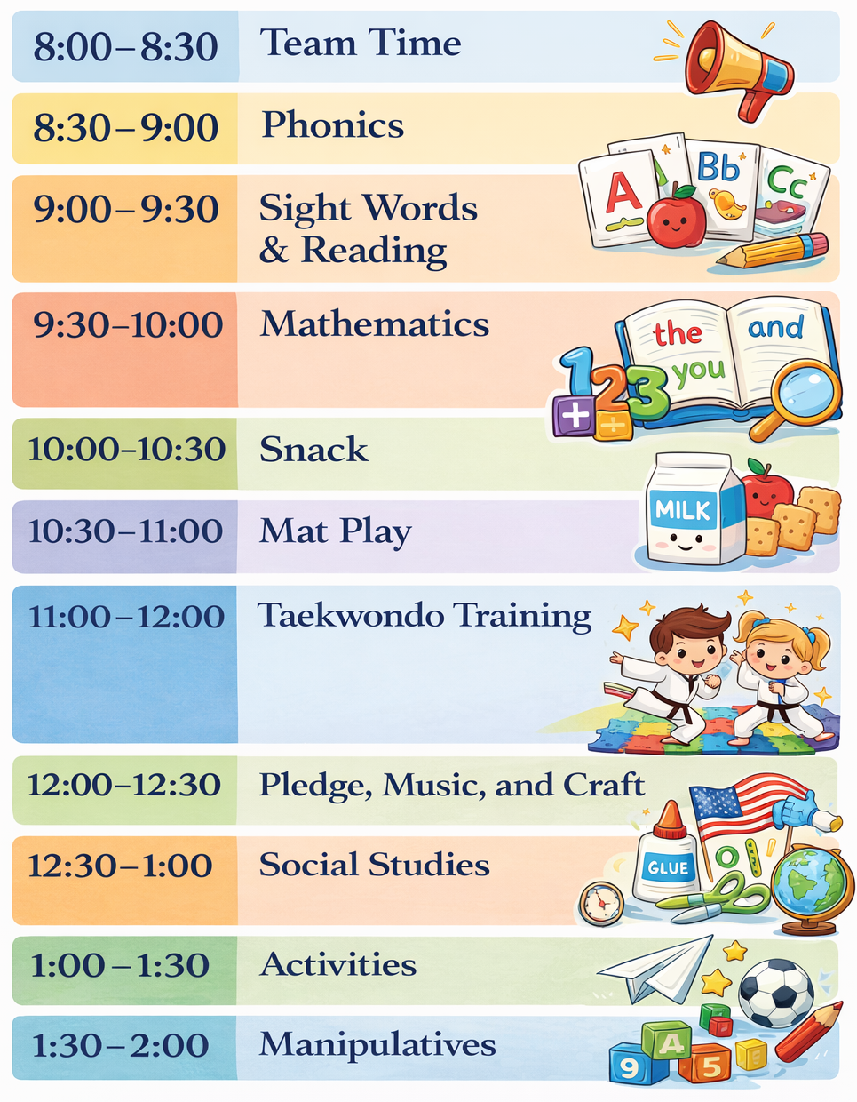

Why Parents Choose Courageous Character
Parents choose Courageous Character because it offers a unique learning environment where students grow academically, physically, and spiritually.
Highlights of our program include:
• Small class size with individualized attention
• Strong academic foundation using Abeka curriculum
• Christ-centered learning environment
• Daily Taekwondo training that builds discipline and confidence
• Hands-on learning activities that keep students engaged
• Leadership and character development built into every day

Prices
Academic Tuition | $5,400 (540/month)
Taekwondo Training | $115/month
Total | $6,550/$655/month
Additional Fees
Application Fee | $150
Curriculum Fee | $500
Taekwondo Testing | $45 per promotion (3 times a year)

